E-commerce Application on IBM Cloud Foundry

**Phase 4: Development Part 2**

**Overview:**

This project aims to facilitate the buying and selling of handmade or artisanal products. It focuses on promoting and showcasing the work of artisans and craftsmen, offering features like product listings, user profiles, robust search and discovery tools, shopping cart and checkout functionality, customer reviews and ratings, inventory management, customer support, marketing and promotions, community and social features, mobile-friendliness, secure transactions, analytics and reporting, and integration with shipping and logistics services. This application celebrates craftsmanship and creativity while connecting artisans with a broader customer base, making it easier for artisans to sell their unique products and for customers to find and purchase high-quality, handcrafted goods.

**Solution:**

We Continue building the e-commerce platform by implementing user authentication, shopping cart, and checkout functionality and we have successfully Implemented user registration and authentication features using a backend server (e.g., Node.js, Python) and Implemented shopping cart functionality, calculate the total, and enable a smooth checkout process.

**Website Layout:**

**Sign up Page:**

* The signup page at Aura Traffic is where you embark on your journey to becoming a valued member of our artisan community. As a new member, you'll unlock exclusive benefits and enjoy a personalized experience, complete with tailored product recommendations and special offers. Join fellow artisans in celebrating the art of creation, all while resting assured that your data is secure and private. Our straightforward signup process is designed for efficiency, and our support team is here to assist if needed. We welcome both seasoned artisans and newcomers to our thriving community. Join us today and embrace the world of handmade creativity. Sign up with Aura Traffic and take your first step into a vibrant world of artistry.

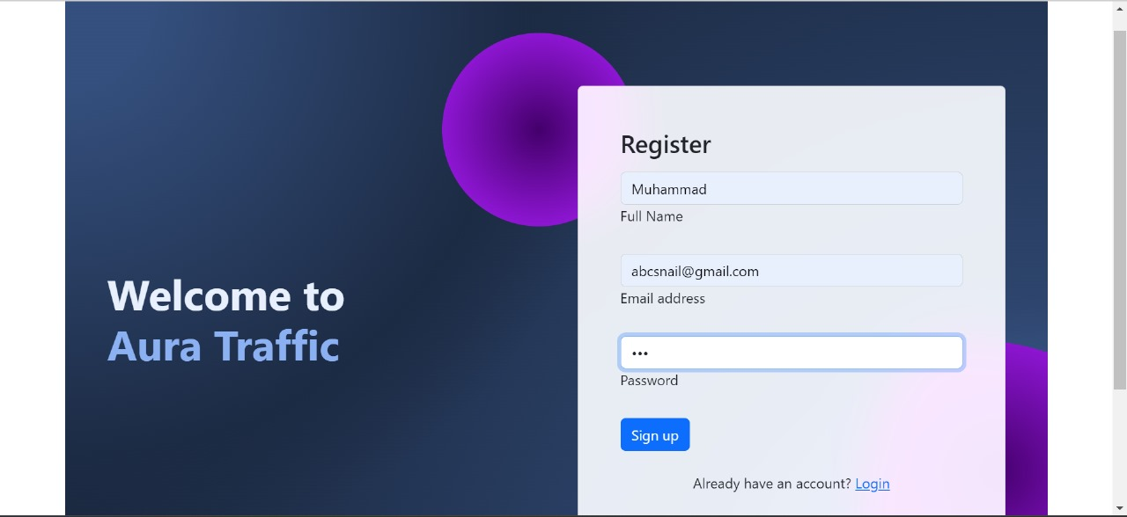

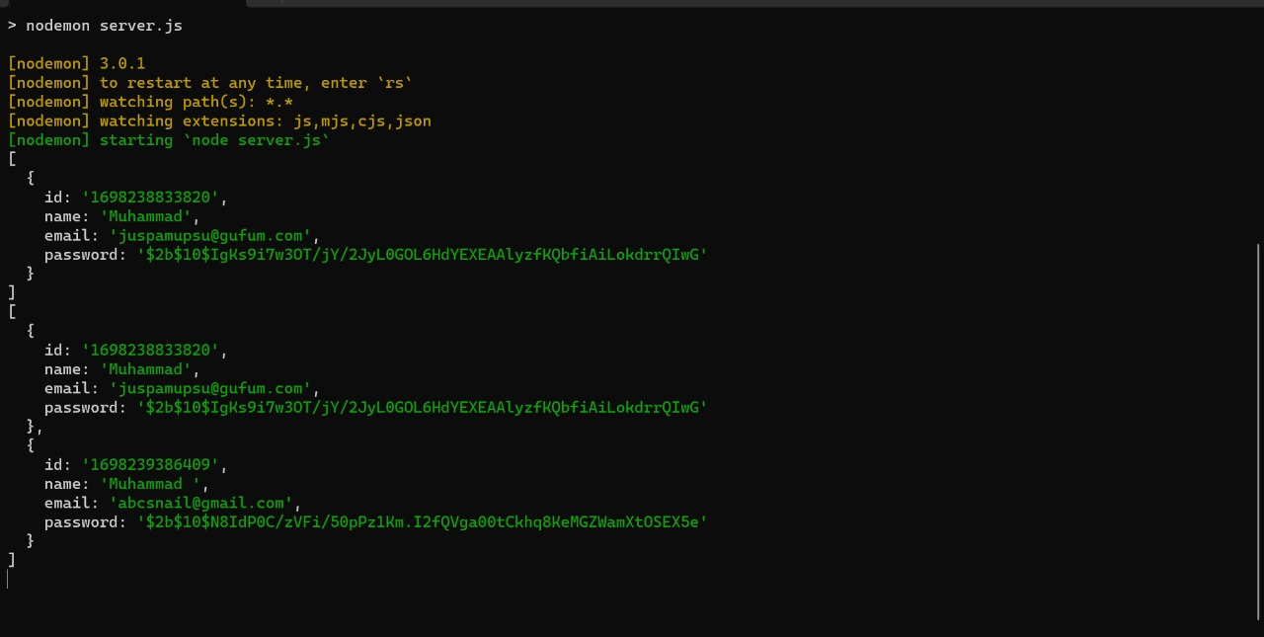

* Registered password will be encrypted and it cannot be misused.

**HTML code for signup:**

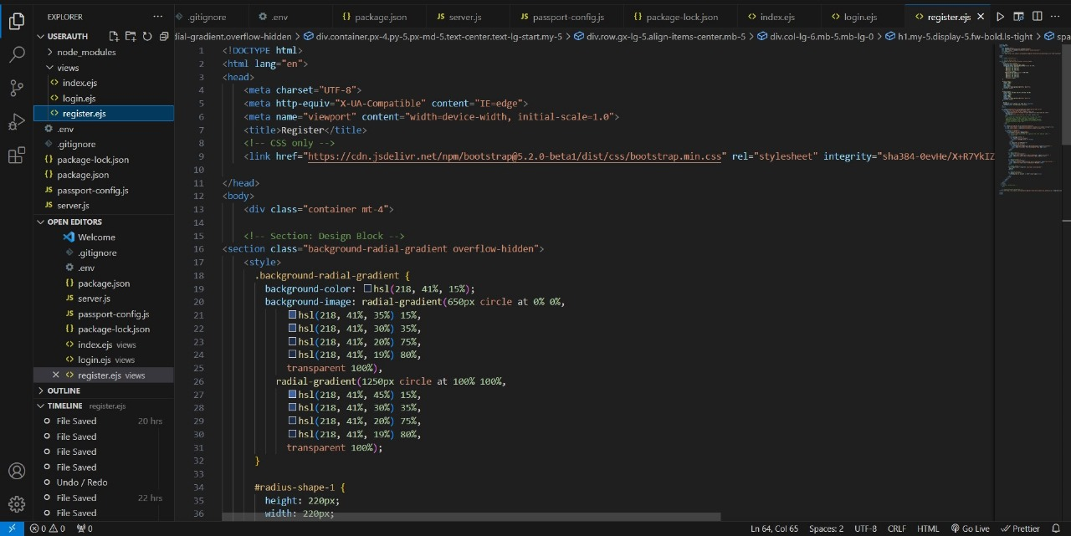

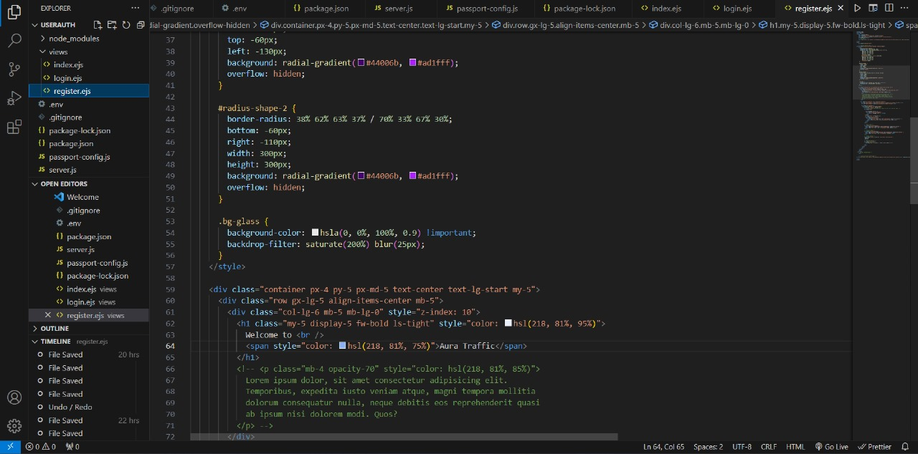

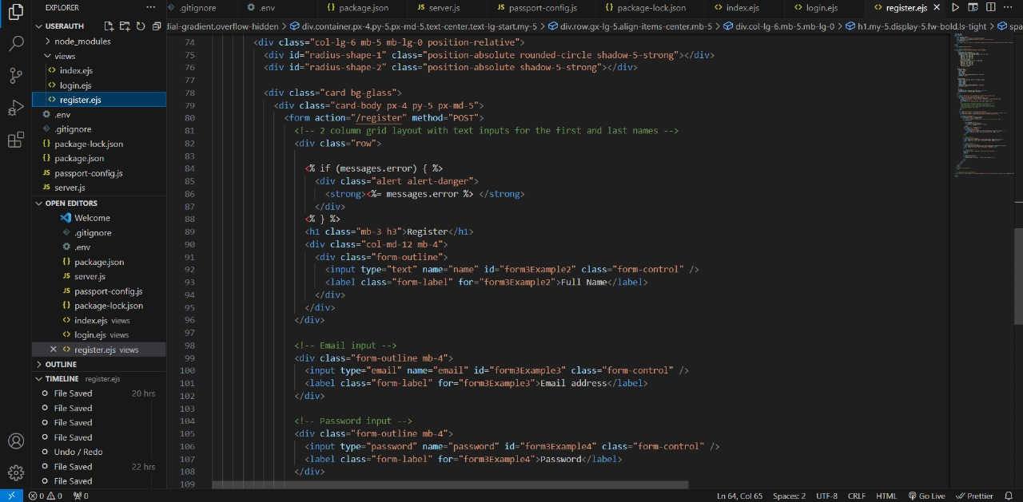

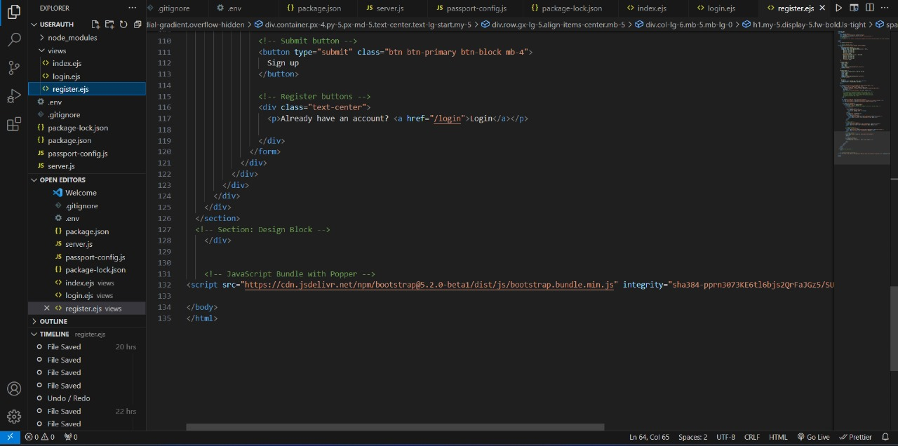

**Login Page:**

* The login page at Aura Traffic offers a personalized entry point to our artisan community. Existing members can access their accounts, while newcomers can sign up for tailored experiences and exclusive offers. Password recovery and enhanced security are prioritized. The login process is made seamless through social media integration, and our support team is ready to assist. Join our thriving artisan network and unlock the world of artistry and craftsmanship today.

**Code for login page:**

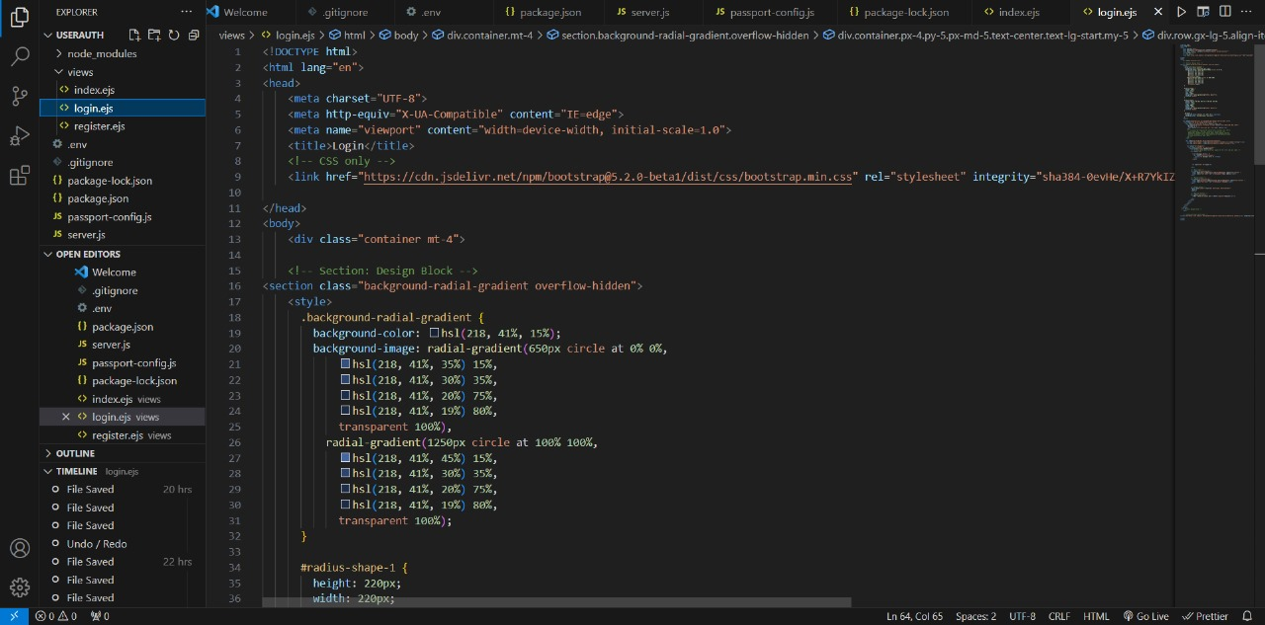

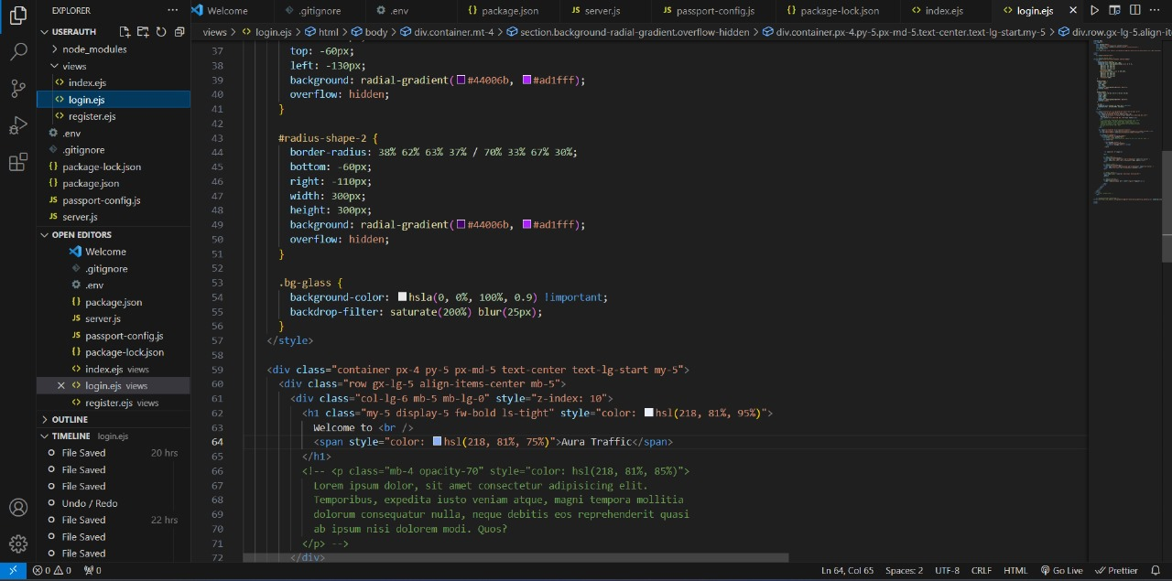

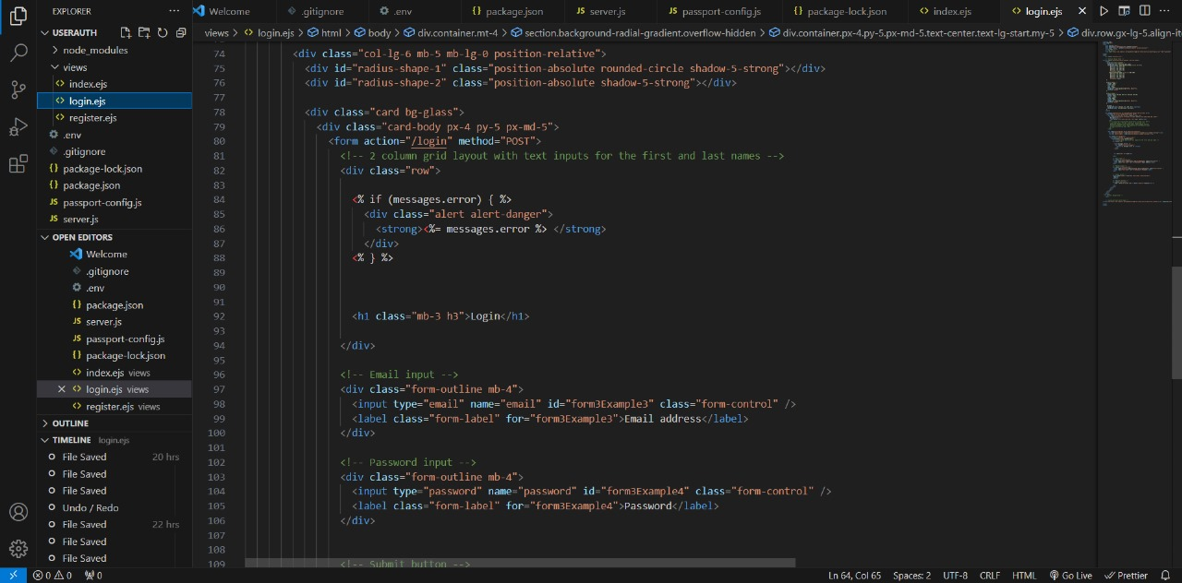

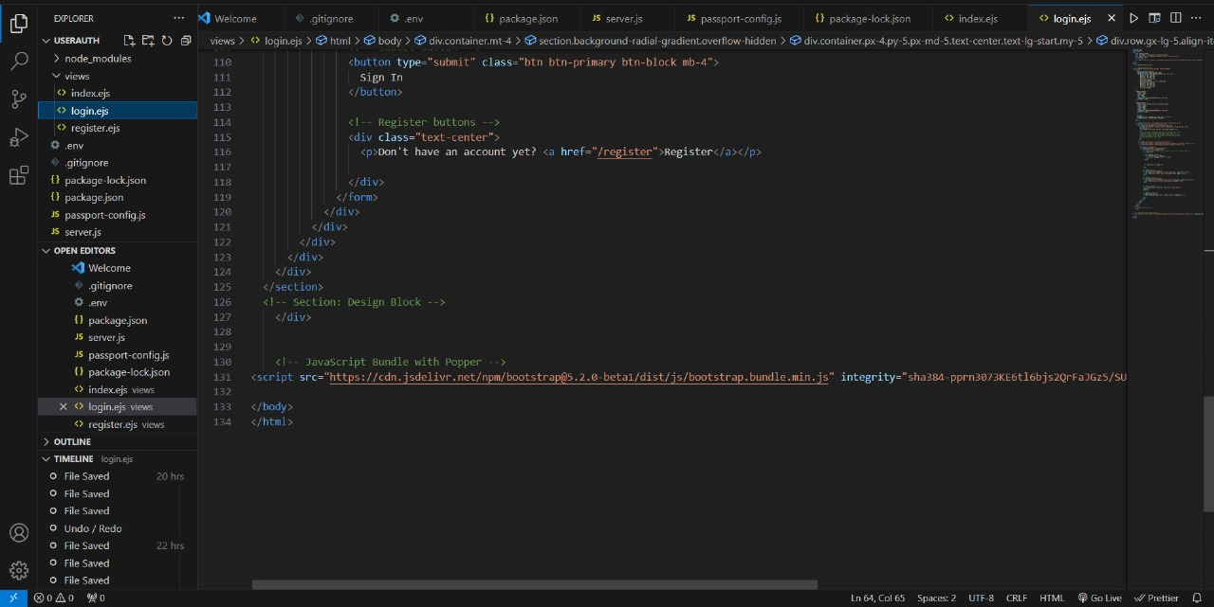

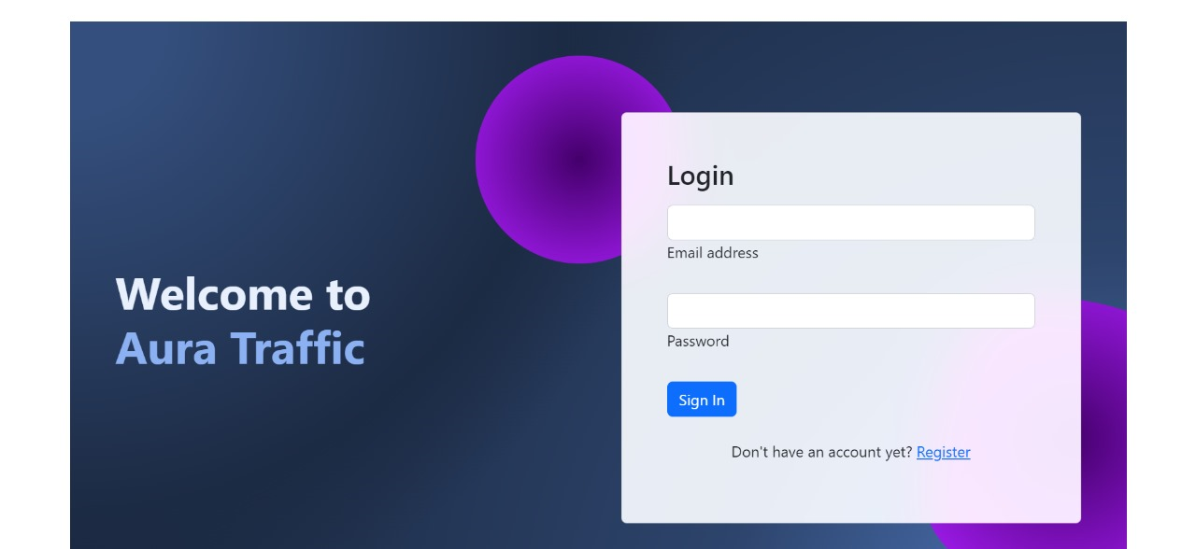

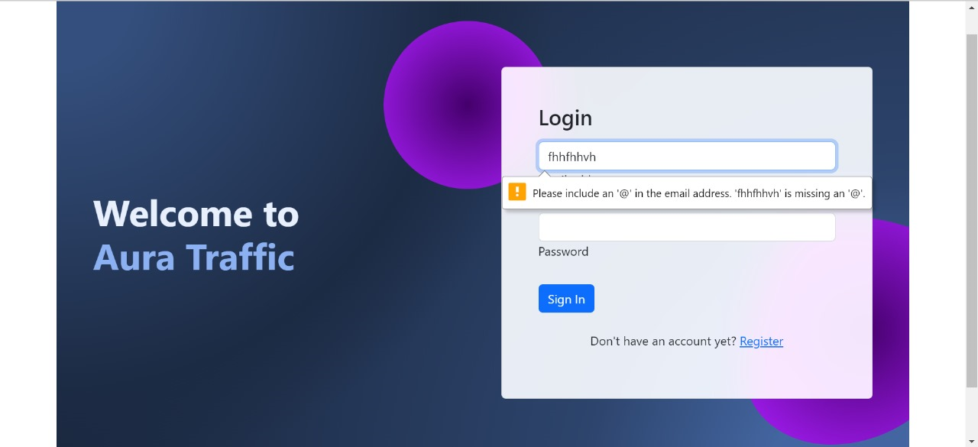

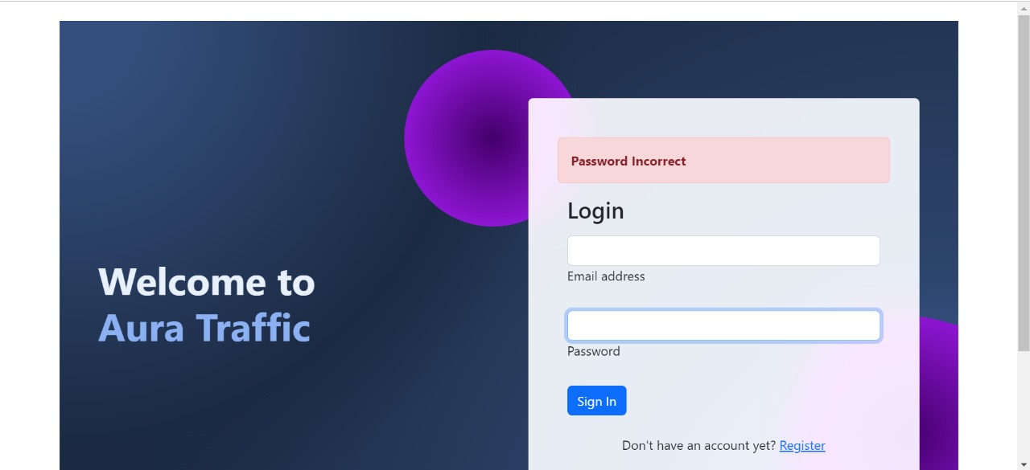

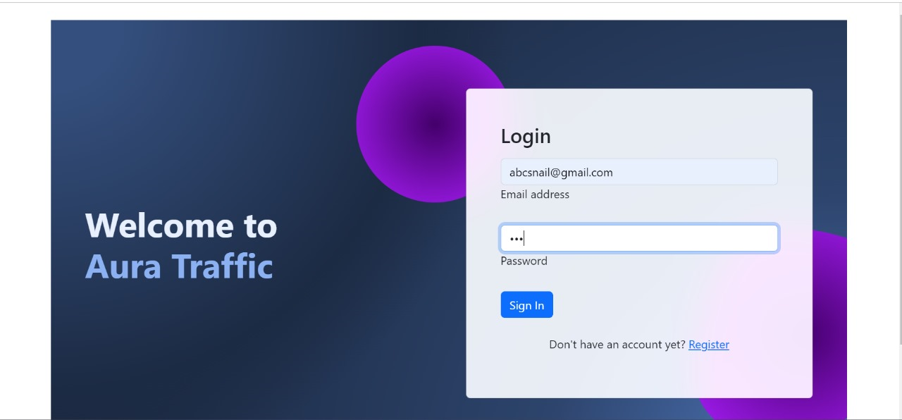

* If we logged in successfully then it will take to the Home page of the website.

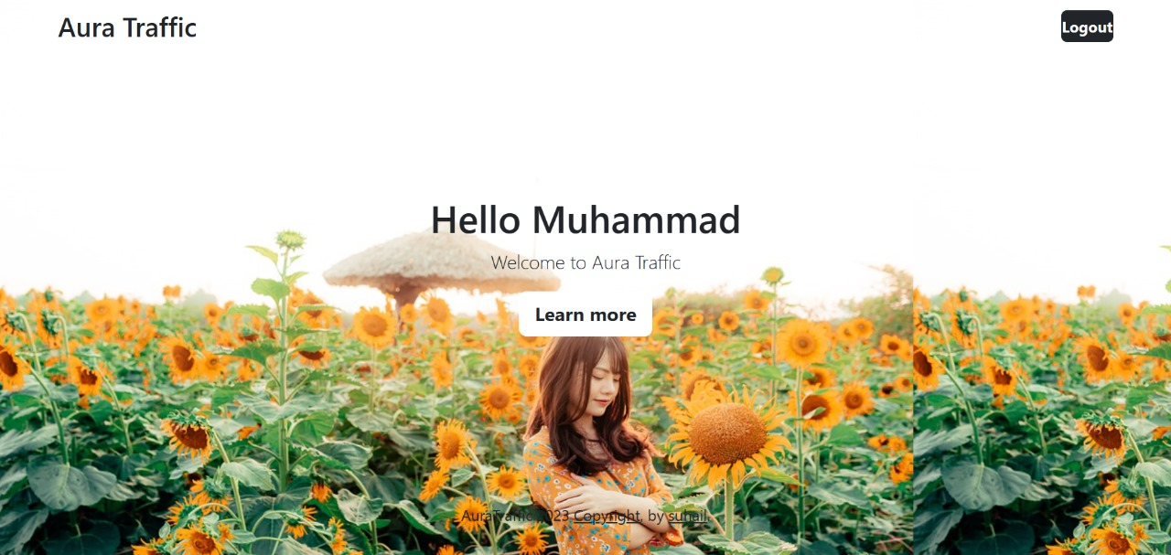

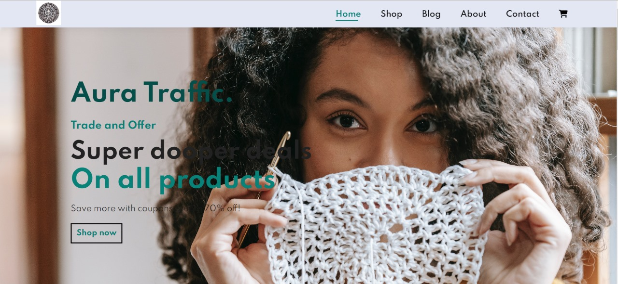

**Server Side code:**

The server-side code for your artisan website is the behind-the-scenes technology that powers the functionality, data handling, and interaction with visitors. It's the engine that ensures your website operates smoothly and securely. Here's a brief description:

Empowering Your Artisan Website: Server-Side Code

Welcome to the heart of Aura Traffic website

Our server-side code forms the backbone of your artisan website, working diligently behind the scenes to provide a seamless and secure experience for visitors like you.

* Data Management: Our code ensures efficient storage and retrieval of artisan profiles, product listings, and blog posts, guaranteeing you quick access to the content you seek.
* User Authentication: It enables secure login and account management, safeguarding your personal data and privacy.
* Customization: The server-side code allows for personalized experiences, from tailored product recommendations to unique account settings.
* Smooth Checkout: It powers the smooth processing of your shopping cart, ensuring your handcrafted treasures are processed securely and accurately.
* Interaction: Our server-side code handles user interactions, such as submitting forms, engaging with comments, and facilitating communication between artisans and customers.
* Scalability: As our artisan community grows, the code is designed to scale, ensuring your experience remains uninterrupted and responsive.
* Security: We prioritize your safety and data privacy, employing advanced security measures and encryption protocols to protect your information.

At Aura Traffic, we believe that the beauty of our handcrafted treasures should be matched by the efficiency and reliability of our website. Our server-side code is here to make that a reality.

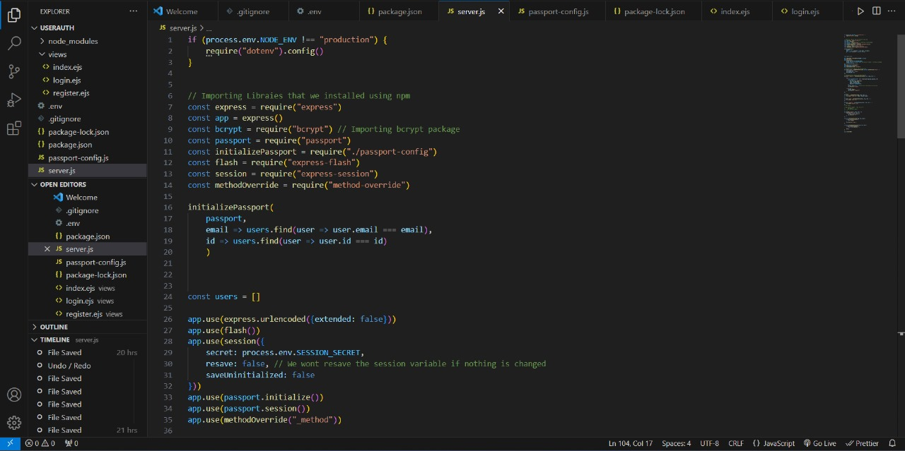

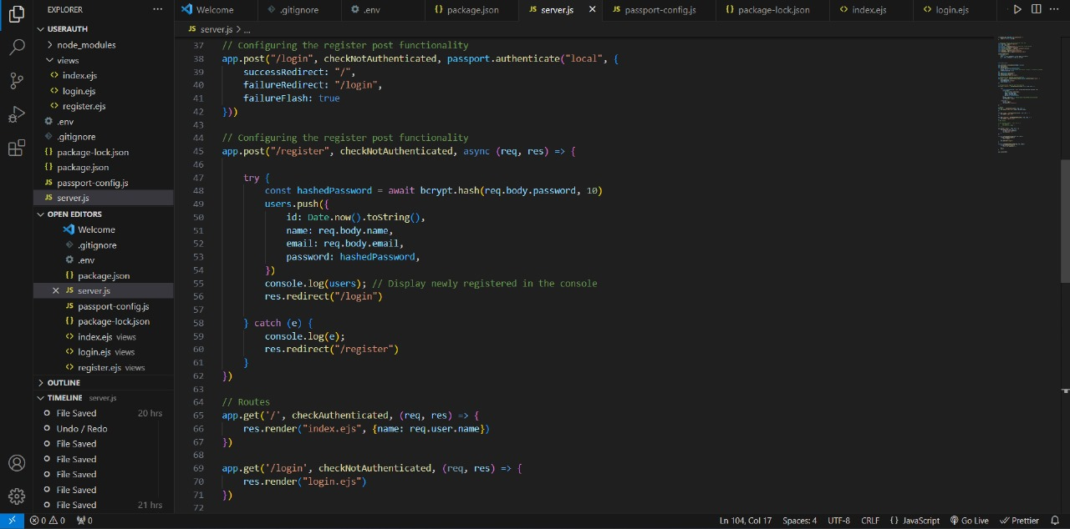

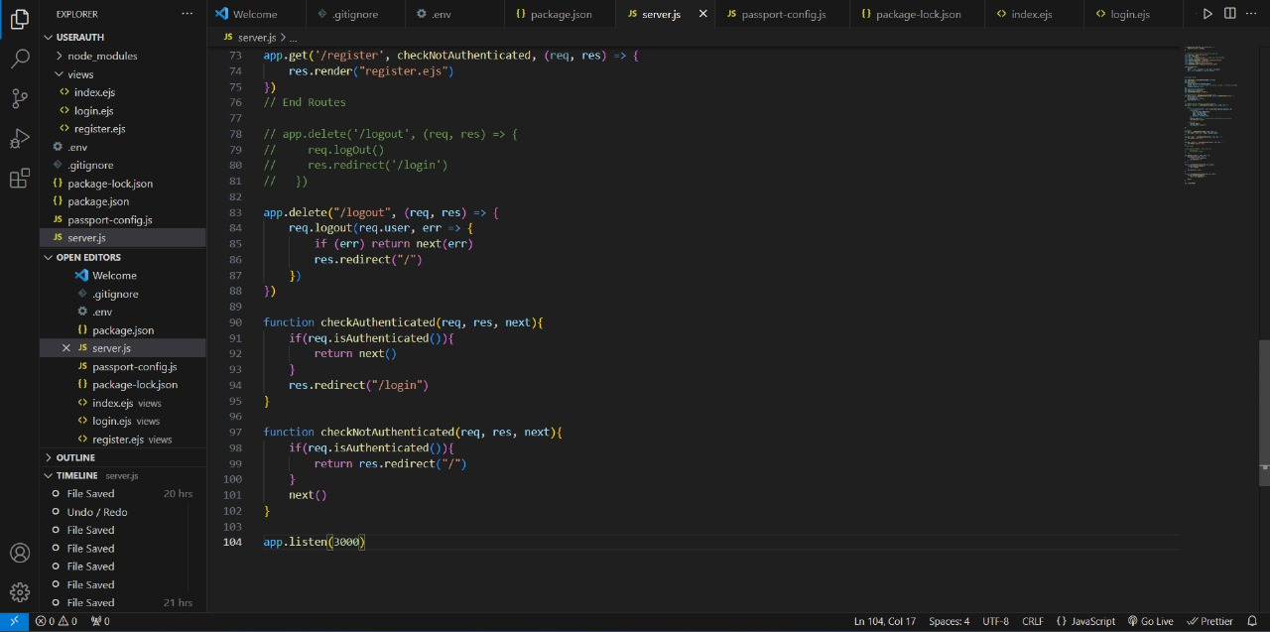

**Shopping Cart Page:**

* Your shopping cart at Aura Traffic is where your artisan treasures come together. Review your handpicked selections, personalize your choices, calculate shipping, and explore special offers. Continue shopping or proceed to a secure checkout with ease. Should you need assistance, our support team is just an email away. Share your cart with friends and family for their input. Your shopping cart is the hub of artistry and creativity, where each product carries a unique story.

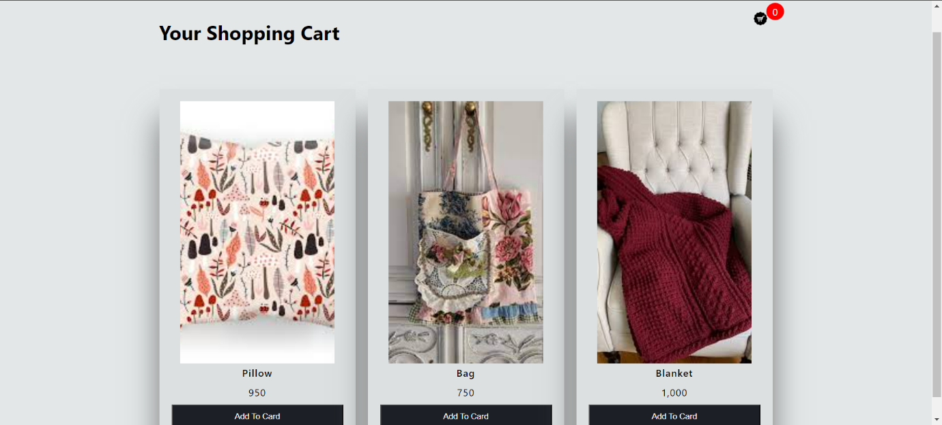

* After adding the product to the cart

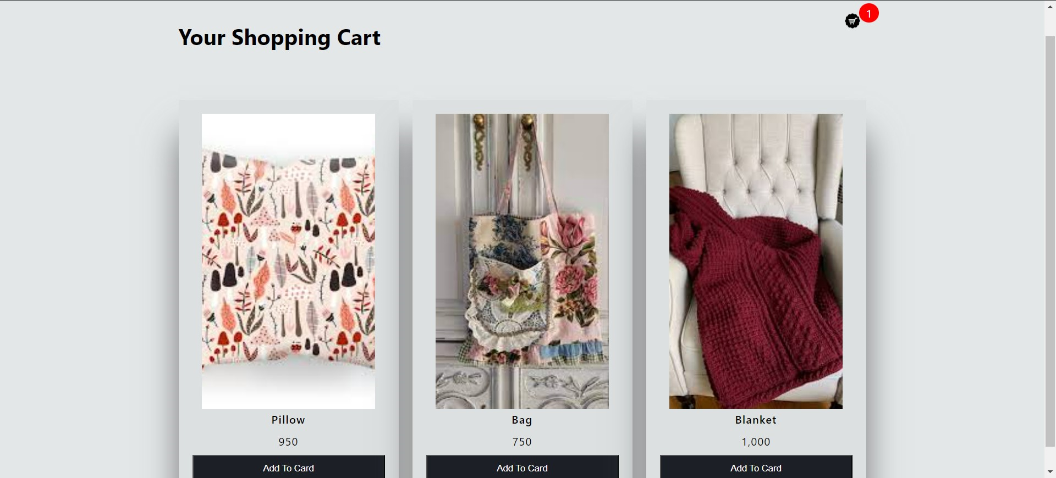

**Summary**:

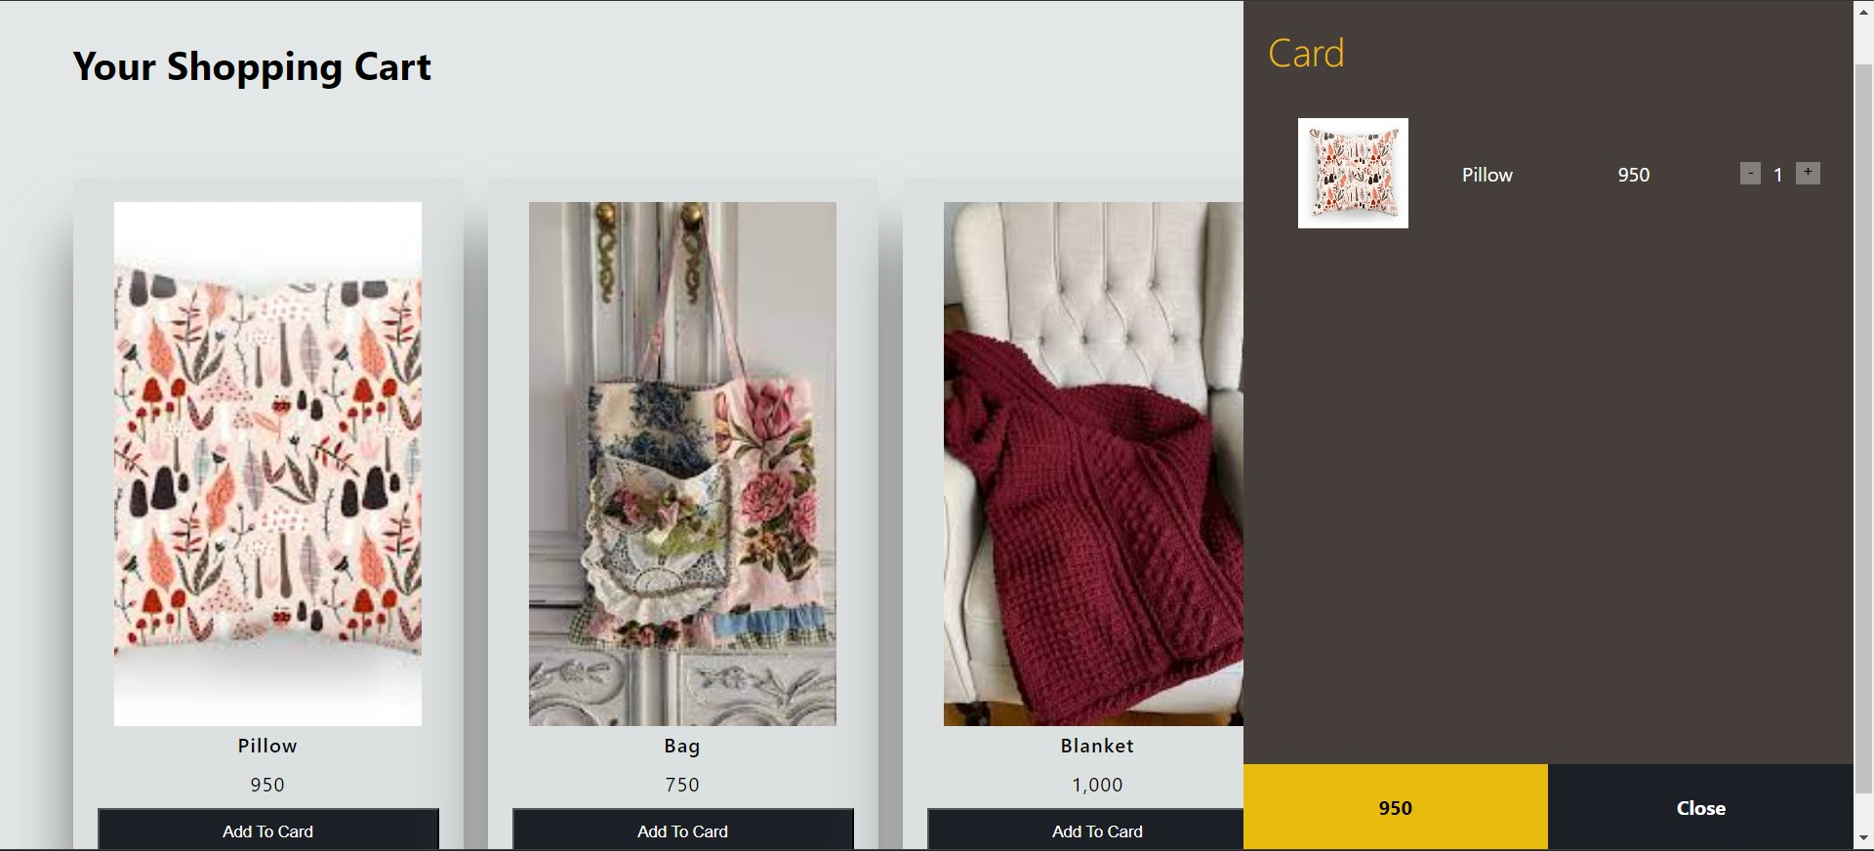

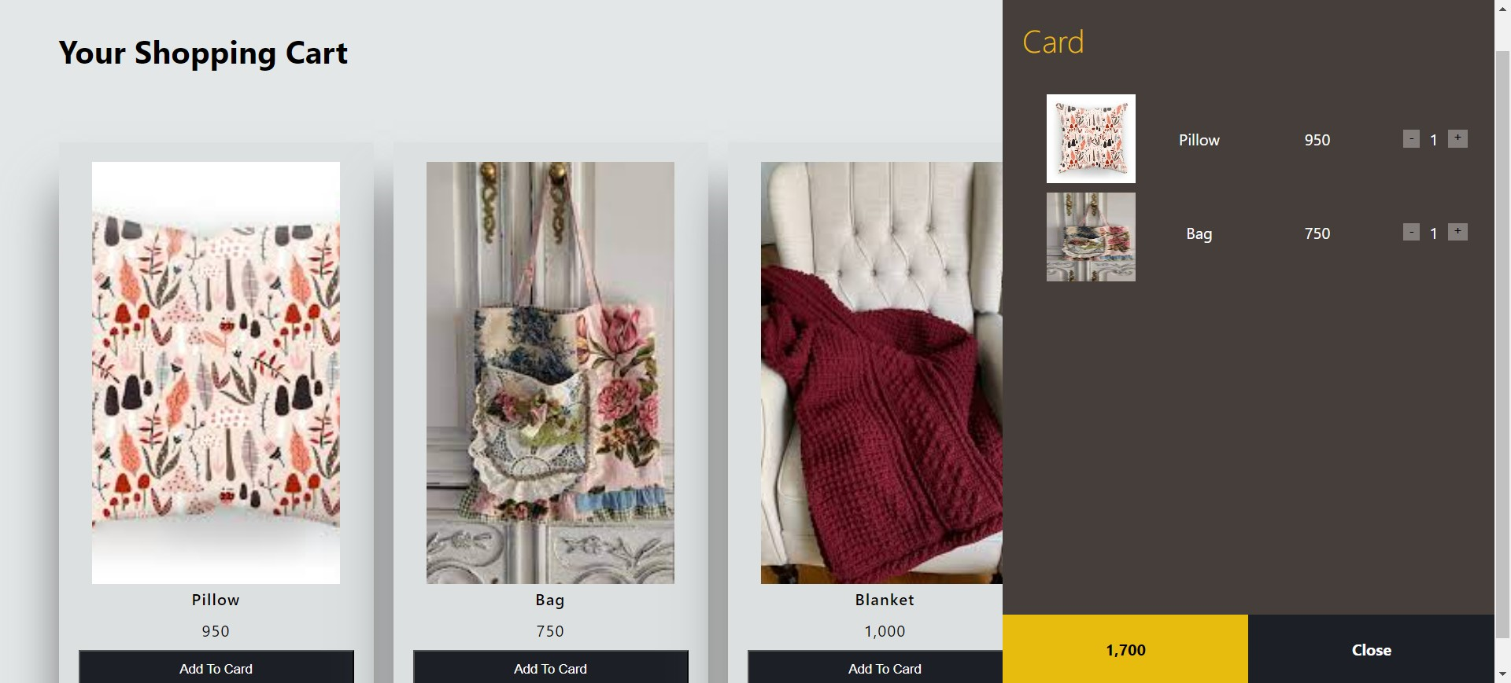

**Home Page:**

* Welcome to Aura Traffic where artistry and craftsmanship intertwine. Our homepage is a portal to a world of unique handmade treasures and the passionate artisans behind them. Explore curated collections, delve into artisan stories in our blog, and discover the possibility of custom creations. Join our artisan community, stay updated, and let the beauty of handcrafted artistry inspire you. Thank you for being part of our creative journey. Start exploring now at Aurra Traffic.



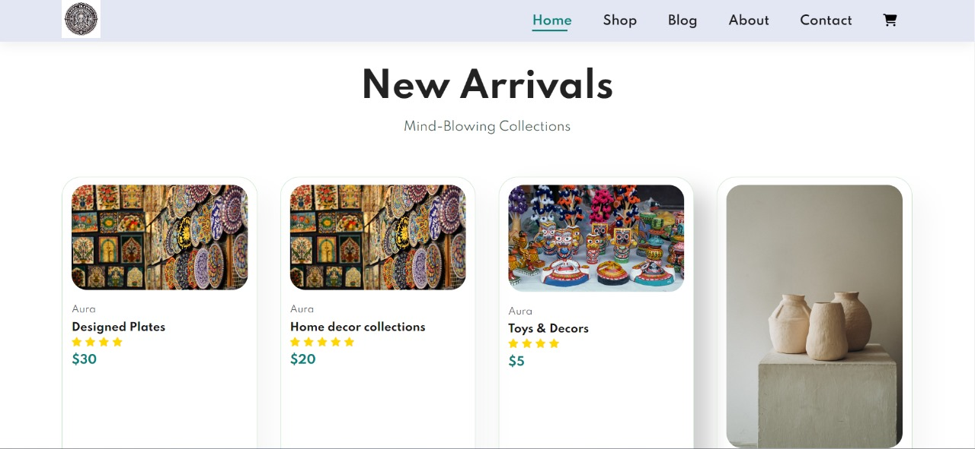

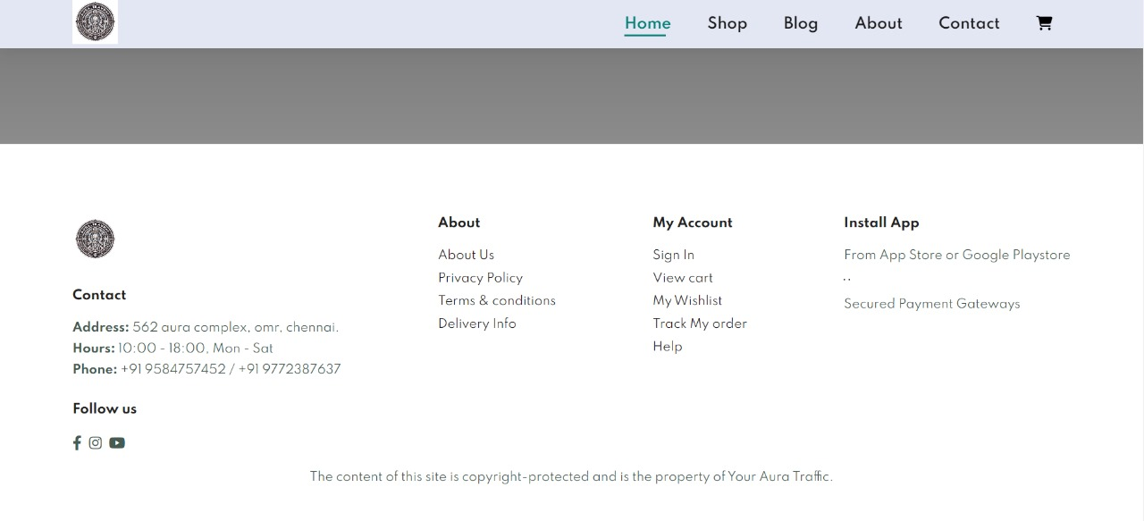

**Code for Home page:**

